SERVICE NOW PROJECT DOCUMENTATION
Importing & Securing Data in ServiceNow

Project Documentation
Submitted By
Team ID: LTVIP2026TMIDS78015
Team Size: 4
Team Leader:
Uma Sahithi Adabala
Team Members:
Sai Sandhya
Tummalapalli Manikant Vinay
Shyamala Yarra

Mentors
Industry Mentor:
No Mentor Assigned
Faculty Mentor:
M Ganesh

Internship / Organization
SmartInternz – Project Phase

Platform Used
ServiceNow Platform

Academic Year
2025 – 2026

1. Introduction
Digital transformation plays a crucial role in managing organizational data efficiently. Many organizations maintain employee training records manually using spreadsheets or disconnected systems, leading to data redundancy, limited visibility, and difficulty in tracking employee training progress.
To overcome these challenges, the Importing & Securing Data in ServiceNow was developed using the ServiceNow platform. The system automates training record management by allowing administrators to import employee training data, link records with employee information, and manage access securely.
This solution replaces manual tracking methods with a structured and workflow-driven automation system within ServiceNow.

Project Objectives
The Importing & Securing Data in ServiceNow focuses on:
- Digitizing employee training records
- Eliminating manual data maintenance
- Linking training records with employee details
- Providing department-wise visibility
- Enabling structured reporting
- Improving data accuracy
- Implementing secure role-based access
- Supporting organizational compliance tracking

2. Project Overview
The Importing & Securing Data in ServiceNow is a Scoped Application developed using ServiceNow Studio.
The system allows administrators to:
- Store employee training information
- Import bulk training data
- Track training completion status
- Link employees using reference fields
- View department information through dot-walking
Users can:
- View employee training records
- Monitor completion status
- Access updated information securely
Previously, training management involved:
- Manual spreadsheets
- Disconnected employee records
- No centralized storage
- Limited reporting capability
This resulted in:
- Data inconsistency
- Reporting difficulties
- Lack of access control
- Increased administrative effort
The implemented system resolves these issues using structured database relationships and automation.

3. System Architecture
The system follows a layered architecture within the ServiceNow platform.

3.1 Presentation Layer
The presentation layer is implemented using:
- ServiceNow Classic UI
- List View Interface
Users interact with:
- Employee Training module
- Training record list view
- Record forms
- Reports and dashboards
User Flow
- User logs into ServiceNow instance
- Opens Employee Training module
- Views training records
- Checks employee department and status

3.2 Business Logic Layer
Business logic is implemented through:
- Table configuration
- Import Sets
- Transform Maps
- Access Control Rules (ACLs)
- Role Management
The application ensures:
- Valid data import
- Structured record mapping
- Secure access control
- Controlled record modification

3.3 Data Layer
The system uses a custom table inside the scoped application.
Primary Table
Employee Training (Custom Table)
Fields Created
- Training Name – String
- Completion Date – Date
- Status – Choice
- Employee – Reference (sys_user)
Each record represents one employee training activity.
The system maintains:
- Record history
- User audit tracking
- Created/Updated timestamps
- Department relationships
All data is securely stored within the ServiceNow database.

4. Implementation Details

Phase 1: Instance Creation
- Logged into ServiceNow Developer Portal
- Requested Personal Developer Instance
- Accessed instance using admin credentials
- Verified development environment

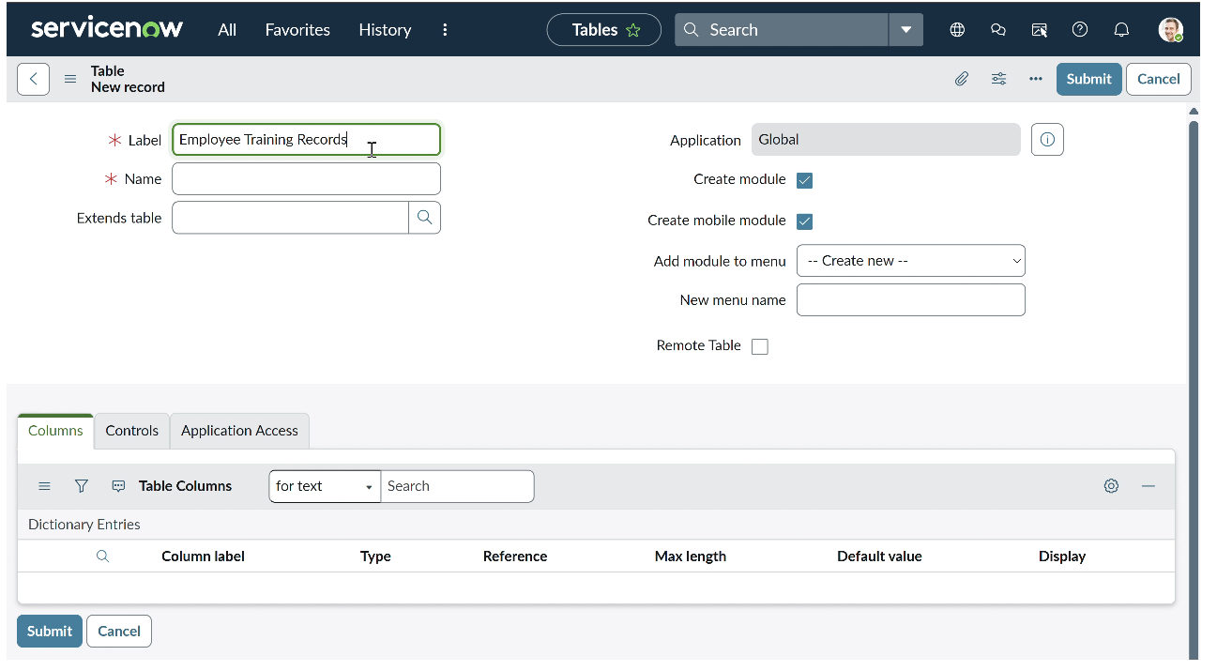

Phase 2: Application Creation
Using ServiceNow Studio:
- Created Scoped Application
- Selected Create from Scratch
- Application Name: Employee Training Management
- User Experience: Classic ServiceNow

Phase 3: Table Creation
Created custom Employee Training table.
Fields Added:
- Training Name (String)
- Completion Date (Date)
- Status (Choice)
- Employee (Reference → sys_user)
Status choices were configured using Dictionary Entries.
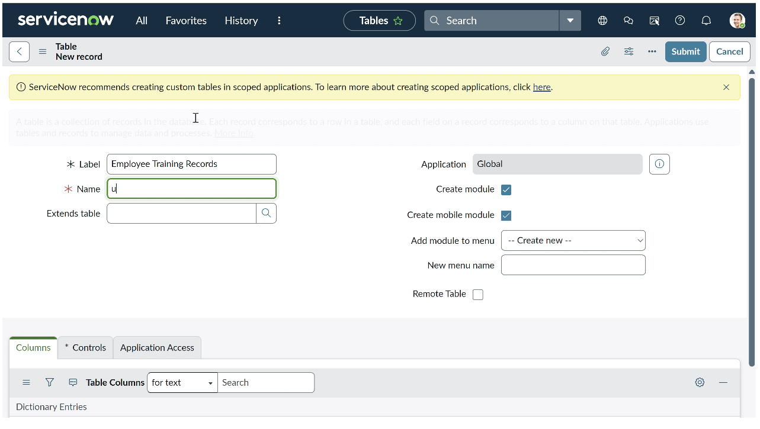
Phase 4: Data Import Using Import Sets
- Uploaded training dataset using Load Data
- Created Import Set Table
- Verified uploaded records

Phase 5: Transform Map Configuration
- Created Transform Map
- Mapped source fields to target table
- Executed transform process
- Successfully inserted records

Phase 6: Dot-Walking Implementation
Dot-walking was used to retrieve:
- Employee Department
- Employee-related details
Department information became visible directly in list view.

Phase 7: Security Implementation (ACL)
Security was enforced through:
- HR Manager Role creation
- Read ACL configuration
- Write ACL configuration
- Role assignment to authorized users
Unauthorized users were restricted from accessing records.

5. Process Flow Lifecycle
The application workflow ensures secure handling of training data.
Workflow Steps
- Training data uploaded through Import Sets
- Records created in Employee Training table
- Employee linked via reference field
- Department retrieved using dot-walking
- ACL validation applied
- Authorized users manage records

Testing and Validation
Comprehensive testing included:
- Import validation testing
- Transform mapping verification
- Role-based access testing
- User impersonation testing
Results confirmed secure and accurate system behavior.

Challenges and Future Enhancements
Challenges
- Initial reference field configuration issues
- ACL permission conflicts during testing
- Import mapping validation errors
Future Enhancements
- Automated training reminders
- Certification expiry alerts
- Department dashboards
- Employee self-service updates

Conclusion
The Importing & Securing Data in ServiceNow demonstrates how ServiceNow can effectively automate organizational data processes. The implementation provides:
- Transparency: Centralized training visibility
- Efficiency: Automated data import and relationship mapping
- Security: Role-based controlled access
- Scalability: Extendable framework for enterprise training management
The project successfully replaces manual tracking with a secure, automated, and scalable ServiceNow solution.

